Sam Houston State Oboe Audition Excerpts, Spring 2024

Bach, St. Matthew’s Passion, Aria 26

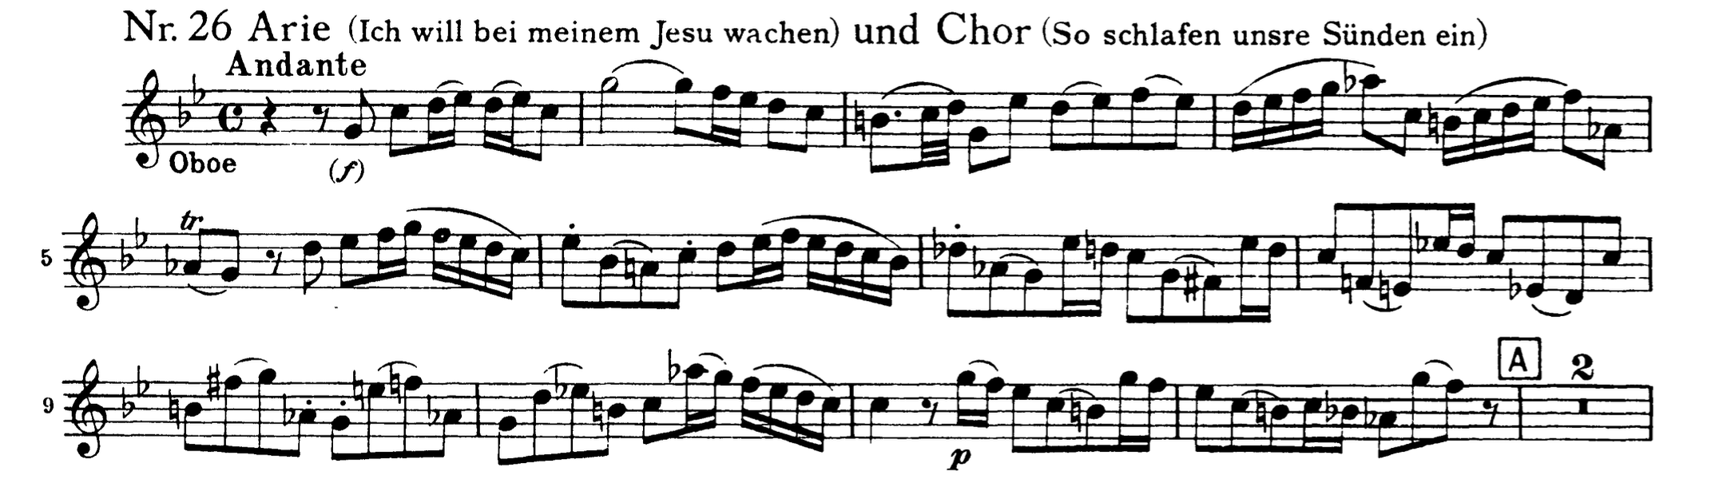

Brahms, Symphony No. 1, mvt. 2
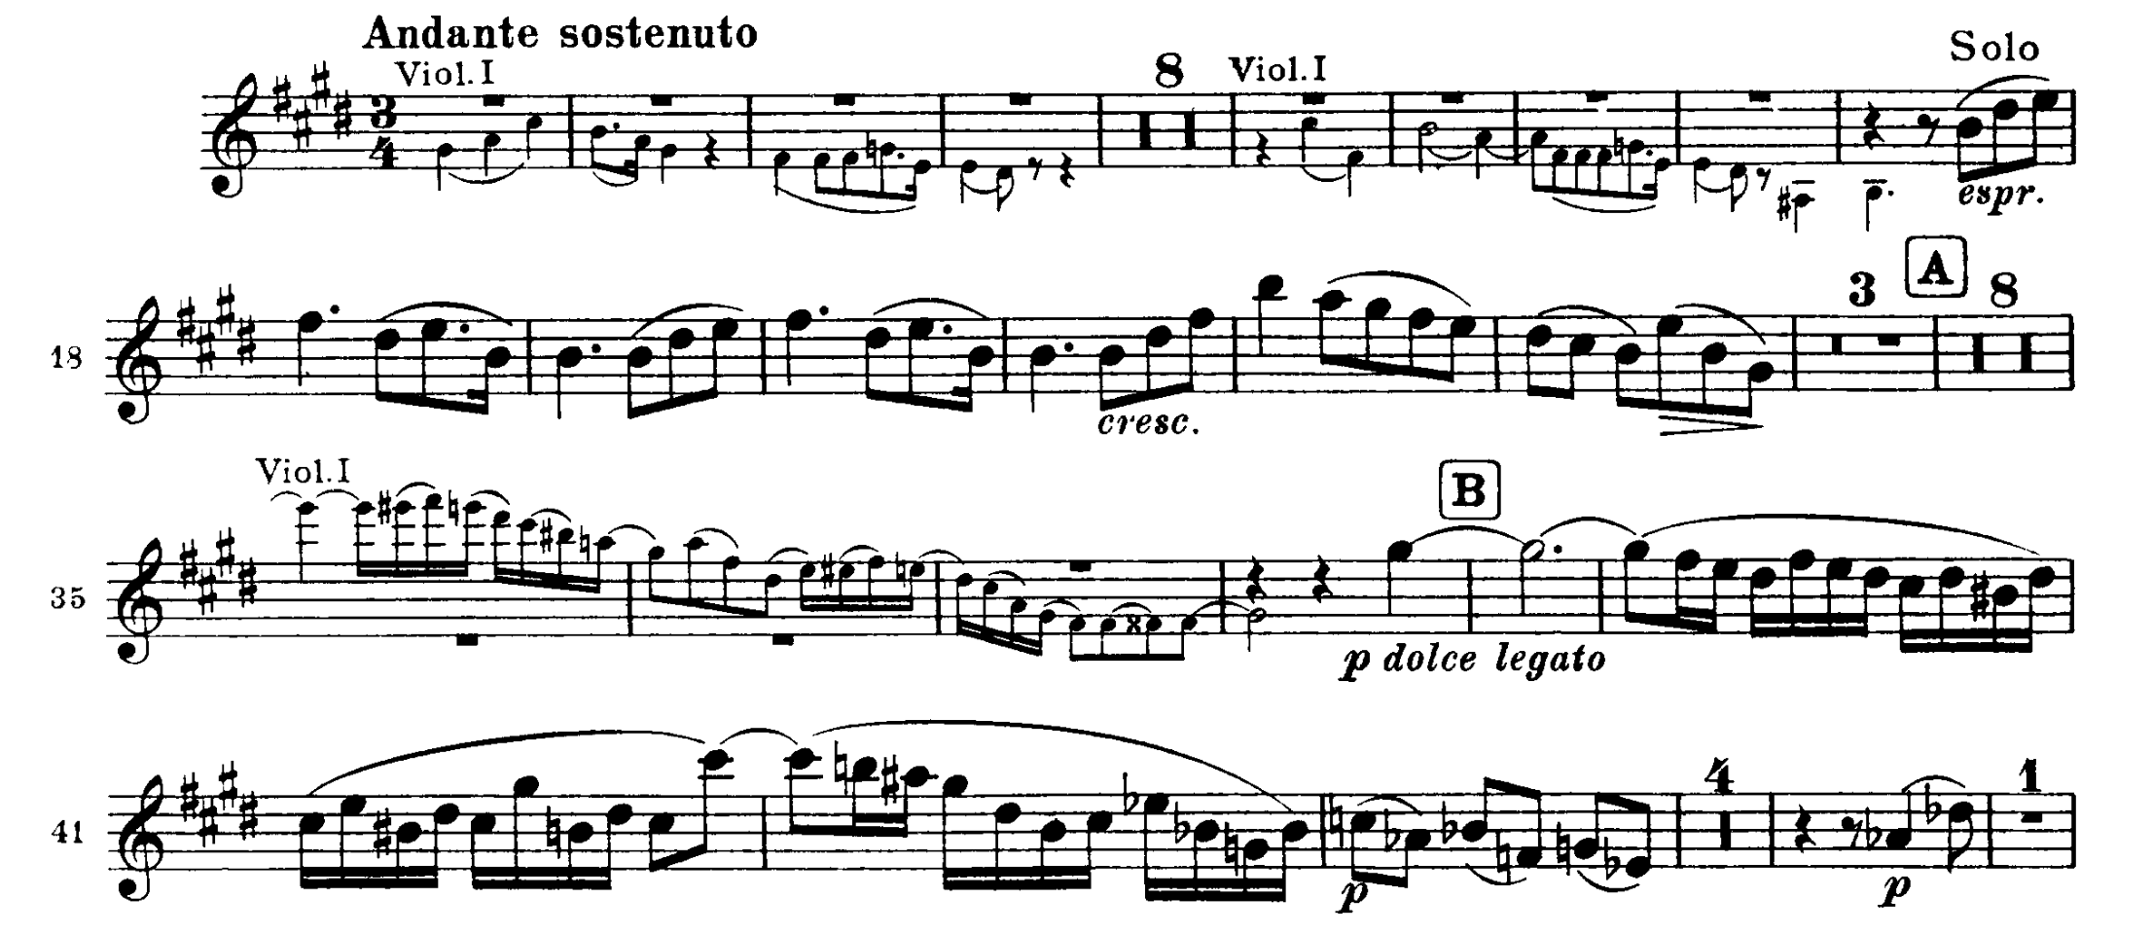

Schubert, Symphony 9, mvt. 2
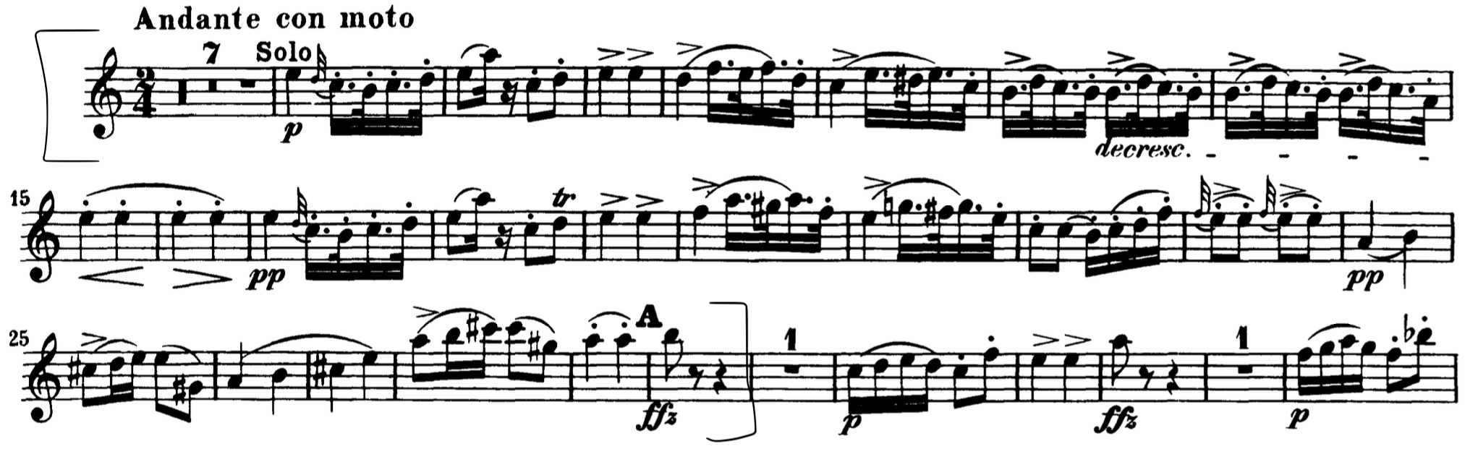

Beethoven, Symphony 9, mvt. 2
